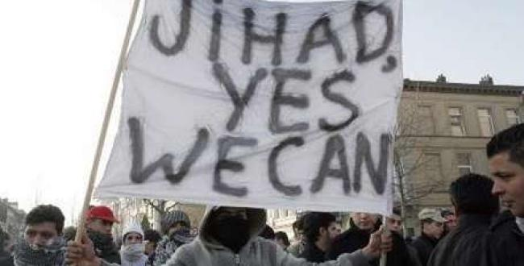

Map
Utrecht, Netherlands
Utrecht, Netherlands

Holocaust cartoon prosecution- double standards?
Published on : 3 September 2009 - 9:50am | By RNW News Desk

A cartoon that claims the number of Holocaust victims is a Jewish exaggeration is punishable by law. The Dutch public prosecutor's office has announced it intends to prosecute the Arab European League (AEL) which put the cartoon on its website. Prosecutors say the drawing constitutes discrimination since it insults Jews as a group.
Last month prosecutors declined to prosecute Dutch anti-Islam politician Geert Wilders for re-publishing Danish cartoons on his website depicting the Islamic prophet Mohammed as a terrorist with a bomb in his turban. Prosecutors then judged that that was insulting to the prophet of Islam and not Muslims as a group. That is the difference with the Holocaust cartoon.
For the AEL this is a clear case of double standards - and this is the reason the group says it declined an offer from prosecutors to avoid a court case if the group was to remove the cartoon from its site.
"This would have gone against the feeling of injustice in our group," said AEL chairman Abdoulmouthalib Bouzerda.
The AEL in fact deliberately put the provocative cartoon, and others too, on its site following the decision not to charge Wilders.
This led to the Centre for Information and Documentation on Israel lodging a complaint about the series of cartoons on the AEL website. This week prosecutors ruled that the Holocaust cartoon was the only one punishable by law.
The cartoon shows two men standing beneath a sign reading "Auswitch" (sic) and beside several dead bodies, saying the victims might not have been Jewish but they still had to "get to six million" - the number of Jews killed in the Holocaust.
When two weeks ago the Public Prosecutor's office offered to drop the case if the AEL removed the cartoon from its website the group did at first do so, but then it put the cartoon back online claiming that the ruling was an instance of double standards.
The Arab-European League is an Arab and Islamic lobby group based in the Netherlands and Belgium.
A spokes for the Dutch prosecutor’s office said:
"That the Danish cartoons are insulting and hurtful is beyond dispute, but the line between hurtful and discriminatory is very thin and as far as we are concerned this cartoon about the Holocaust is just over that line

