 | Media Diversity Institute

MIRRORING IMAGES: ETHNIC MINORITIES IN THE SOUTHEAST EUROPEAN PRESS
MEDIA DIVERSITY INSTITUTE
Dr Snjezana Milivojevic, author

RESEARCH REPORT

ABSTRACT
Critical analysis of discriminatory reporting is vital in developing a more responsible press.
The following comparative analysis highlights some of the ethnic stereotypes and prejudices common throughout the region. It also reveals how the media perpetuates them.
This research report is based on content analysis of the mainstream press in 10 Southeast European countries. It focused on minority coverage, in the region which has experienced major inter-ethnic conflicts during the past decade. At the time of monitoring in late 2001, conditions among the countries differed markedly - from ongoing ethnic conflict (Macedonia), to those close in time or proximity to conflict (Serbia, Kosovo, Albania, Montenegro), to post-conflict situations (Bosnia, Croatia), to countries without recent violent ethnic confrontation (Bulgaria, Hungary, Romania). As ethnic minorities constitute a significant portion of the population in each country, successful transition in those nations require more democratic and tolerant minority policies.
Media coverage conditions public perception of otherness and indicates broader political strategies of inclusion, or exclusion of minorities in political life. Major daily newspapers influence the formation of dominant political discourse, usually close to official policy position, but also affect everyday understanding of events.
ABOUT THE MONITORING
Monitored and analyzed content was taken from one month's reporting by 10 mainstream newspapers in 10 Southeast European countries in November 2001. The quality of ethnic minority coverage was analyzed to compare forms of discriminatory treatment and journalistic practices that perpetuate it. Ethnic minorities constitute a significant part of the population throughout the region, but during the past decade these differences were often misused and transformed into sparks for violent conflict. The objective of this comparative content analysis is to reveal underlying similarities between countries' differences with regard to:
- relations between social stability and levels of discrimination and press intolerance;
- widespread, deeply-rooted stereotypes and prejudices that govern common understanding of minority-majority relations;
- similar journalistic standards and practices resulting in intolerance and unfair treatment of diversity issues.
Two major newspapers per country were monitored. They were selected for their large circulation, non-state or non-party ownership, and for being representative of press diversity in their countries. Those newspapers are:
- Albania: Albania and Shekulli;
- Bosnia and Herzegovina: Dnevi avaz and Nezavisne novine;
- Bulgaria: Trud and 24 casa;
- Montenegro: Vjesti and Dan;
- Croatia: Jutarnji list and Vecernji list;
- Kosovo: Koha ditore and Bota sot;
- Hungary: Nepsabadsag and Metro;
- Macedonia: Dnevnik and Utrinski vesnik;
- Romania: Adevarul and Libertatea;
- Serbia: Politika and Blic.
Each newspaper's entire contents was analyzed, and coverage of all ethnic minorities included. Methodology was designed to provide comparative insight into regional characteristics but, also, to capture specifics of minority coverage in each country.
This research is part of a larger educational project of Media Diversity Institute aimed at capacity building for media and non-government organisations interested in diversity reporting. One of the project objectives was the development of the Media Monitoring Manual. This research served as a form of inter-active training - a proposed research protocol was tested through this monitoring mission. In the process, media analysts from various countries, through their common training and work, formed a team suitable for further comparative research.
Project author Dr Snjezana Milivojevic, of the Institute of Social Sciences, Belgrade, received project support from several people. Project advisory board members are Dr Vera Messing (Center for Independent Journalism, Budapest), Professor Terhi Rantanen (London School of Economics and Politics), Professor Colin Sparks (Westminster University, London) and Professor Brian Winston (Westminster University, London). The monitoring team consisted of nine analysts from the region: Ilda Londo (Albania), Nevena Rsumovic (Bosnia and Herzegovina), Danail Danov (Bulgaria), Igor Kanizaj (Croatia), Dr Vera Messing (Hungary), Anton Berishai (Kosovo), Antoaneta Ivanova (Makedonia), Georgiana Ilie (Romania) and Ana Solovic (Montenegro, Serbia).
The European Commission funded the project.

MAJOR RESEARCH FINDINGS
I POLITICAL STABILITY AND MINORITY COVERAGE
Both the quantity and degree of politicisation of conflict-related coverage increases under conditions of political instability and disharmony in ethnic relations. As conditions stabilise, both the amount of coverage and level of intolerance for ethnic differences decrease.
Conflict resolution may also be followed by increased invisibility and ignorance of ethnic actors or issues as a form of their exclusion from public life. In the absence of conflict, attention of the press quite often turns to minorities in other countries - that is to say the minority there that is of the same ethnicity as their country's main group - rather than domestic minorities issues in their own country.
General press trends split the regional press into two groups:
FIRST GROUP: AREAS EXPERIENCING VIOLENT ETHNIC CONFLICTS OR THOSE IN PROXIMITY TO VIOLENT ETHNIC CONFLICTS
Macedonia, Serbia, Montenegro, Albania and, with certain differences, Kosovo
General: Conflicts get more coverage, between 10 and 20 percent over the regional amount. Highly-politicised reporting, more visible discrimination, isolation of individual ethnic groups, and highly interpretative reporting are more visible here.
MACEDONIA (318 articles, 19.83 percent of the total sample)
Dominating the monitored coverage were: constitutional changes, a general amnesty and disarmament of paramilitaries. More than half of all articles were about violent confrontation with the Albanian minority; an additional quarter was about demanded constitutional changes. Relations with the Albanian minority were the only minority issue and Albanians was the major ethnic group covered - they made up 80 percent of all actors. Only Serbian and Roma minorities made a significant appearance in the press. Ten times more articles had more discriminatory headlines than discriminatory content and with rare exceptions (two articles about Roma) they were always about Albanians. The press is generally very interpretative - less than one quarter of monitored articles was news stories, the remaining three-quarters were various feature articles, editorials and letters to the editor.
SERBIA (219 articles, 13.65 percent of the total sample)
Half of the analysed items concerning ethnic minorities was devoted to parliamentary elections in Kosovo, and presented only from a minority angle. Serbian community election participation is the focus, and the whole event is defined as a test of the minority policy for new Kosovo authorities. The Serbian minority in Kosovo is used as an instrument -- primarily, politicians represent them from Belgrade and their activity is measured according to policies in Serbia. Final decisions on election participation are expected from Belgrade. The most frequently covered actors are almost equally, Albanians (42 percent) and Serbs (41 percent). Roma and Bosniacs get little note, at 4 percent each, and other ethnic groups are barely mentioned. Openly discriminatory articles are rare (around 3 percent) but there are more discriminatory headlines (nearly 10 percent) - almost always about Albanians.
MONTENEGRO (196 articles, 12.22 percent of the total sample)
Monitoring points to the importance of covering ethnic minorities in Montenegro's prospects for national independence. The presses are highly polarised, politically, which also affects minority coverage. An inclusive reporting strategy makes minorities and their issues extremely visible. Coverage is also less conflict-based and more oriented toward everyday action and minority policy, but this only applies to the significant ethnic groups of Albanians and Bosniacs. Other Montenegro media, with a different political orientation, is more tuned to regional issues, primarily Kosovo, Macedonia and Croatia. Discriminatory articles are very rare (only two), but more articles have discriminatory headlines (around 10 percent), most often concerning Albanians.
ALBANIA (179 articles, 11.26 percent of the total sample)
The proximity of violent ethnic conflicts involving the Albanian ethnic community in bordering Kosovo and Macedonia directly influences the domestic political scene. Only one of the analysed articles is about minorities living in Albania, dealing with Roma cultural life. Three fourths of the articles are about Albanians living abroad and the remaining fourth is on Kosovo non-Albanians. There are no openly discriminatory articles but there are discriminatory headlines (around 7 percent) and much of the interpretative coverage is editorials, totaling 10 percent.
EXCEPTION: KOSOVO (77 articles, 4.8 percent of the total sample)
The first elections after the arrival of international forces were treated as an ordinary political event by the press. There was an extremely small number of articles about minorities. The Serbian minority's possible non-participation in the elections was only presented as a problem in a single ethnic group, and treated as a minor issue. An obvious minimising of ethnic issues and groups came as a result of post-conflict changes in the majority-minority situation. Serbs were seen as an insignificant minority rather than in any dominating role. Almost a quarter of the articles written during the monitoring period carried heavy discriminatory reporting and was always about Serbs.
SECOND GROUP: POST-CONFLICT SOCIETIES OR THOSE WITH AN ABSENCE OF RECENT VIOLENT CONFLICT
Hungary, Bosnia and Herzegovina, Croatia, Bulgaria and Romania
General: Less minority coverage, between 5 and 10 percent of the total for the region. More emphasis on minority policy, everyday life and individual ethnic incidents. Each country's media tends to cover minorities in other countries - that is to say the minority there that is of the same ethnicity as their country's main group - rather than domestic minorities issues in their own country. A higher level of discrimination is seen in post-conflict nations than in this area's countries without recent violent conflict.
HUNGARY (160 articles, 9.98 percent of the total sample)
The fairly high amount of ethnic coverage in evidence is probably connected to one important event - the introduction of a status law concerning Hungarian minorities in neighboring countries. The law sparked plenty of debate and media attention for one fifth of the analysed content. A lot of attention was devoted to Hungarian minorities in the region - they are actors in almost 40 percent of the monitored articles. The most extensively covered minority are Roma, with a quarter of the stories concerning them. Roma are usually reported in conflict context, and one third of articles with discriminatory headlines are about them. Articles about Jews also often carry discriminatory headlines: four cases in over 13 analysed articles were noted.
BOSNIA AND HERZEGOVINA (129 articles, 8.04 percent of the total sample)
One newspaper in BiH was selected from the Federation and one from Republika Srpska, with a very similar pattern emerging in both regions, but with different minorities in focus. Minority issues are a little more prominent in the Federation's press. Events from the recent past are an important issue at almost one quarter of all articles about consequences of recent fighting. Kosovo is slightly ahead of Macedonia in regional issue coverage. More articles are written about Serbs than Croats, but Bosniacs is rarely treated as a minority. The constitutional status of the three major ethnic groups is debated more than the position of minorities outside these groups. Jews is the only other minority group given significant coverage. There are no openly discriminatory articles, and the general tone is less conflict-driven than in other regions, possibly because of new strict media regulations.
CROATIA (114 articles, 7.11 percent of the total sample)
Analysis of newspapers shows that post-conflict reporting still strongly emphasizes the past. Half of the articles on minorities are about Serbs and very many of them (almost a third) are very discriminatory. Articles about Serbs mostly focused on recent war crimes and even when not openly discriminatory, such a focus paints a negative picture of the whole group. Out of nine articles about women, eight is about a Serb woman convicted of war crimes. Croats living abroad also received considerable attention, for about a quarter of the surveyed articles and Jews were the only other minority with significant coverage.
BULGARIA (108 articles, 6.73 percent of the total sample)
Coverage of minorities in a country without recent violent conflict is generally less antagonistic. The proportion of discriminatory coverage monitored in the Bulgarian press is not much less than elsewhere, especially on material concerning the largest ethnic groups. Turks and Roma, was the most heavily covered - together they attracted nearly 70 percent of the coverage. Conflict reporting is nearly completely absent. Focus leans toward minority policy or various everyday life activities. Close to 10 percent of the articles about Turks have discriminatory features. Five articles was about women including three focusing on the Roma: one on a fortuneteller, another about a little girl getting married, and another about a woman connected to the murder of her baby.
ROMANIA (104 articles, 6.48 percent of the total sample)
Although not extensive, minority coverage during the monitored month was very conflict oriented and quite often discriminatory. Roma and Hungarian minorities dominate the press, and they are actors in nearly 80 percent of the related articles. Conflict issues are very much in evidence with close to 40 percent of the articles on long-lasting, non-violent conflicts or various individual incidents. Crime dominates reporting about minorities in everyday life situations (almost 45 percent), and the actors are always Roma. The majority of discriminatory articles, which total around one fourth, are also about Roma. Women are actors on only three occasions and all of them are Roma. One is about a helpful neighbour, another on a drug-addict mother, and one about a victim of Roma pimps and drug dealers.

II CONTENT OF THE COVERAGE  1. MAJOR TOPICS  Conflict, minority policy, everyday activities and regional ethnic issues were designated for monitoring after the pilot study results indicated that they were the most frequent topics.  Items were classified according to overall content qualities, topic choice, journalistic approach and type of narrative. Group conflict issues included articles on violent ethnic clashes along with various individual non-violent incidents, because both refer to inter-ethnic conflicts. Articles on political regulation of minority status were classified under minority policy, while the everyday life topic applied to texts about culture, sport, business and other minority group activities. Ethnic issues in the region were also analysed as they often influence domestic minority-majority relations.  Conflict and regional issues each account for about one third of the stories. One fifth of the articles cover various everyday activities, where one sixth is devoted to minority policy issues.  Articles often deal with more than one issue and do not fit neatly in the research categories. A majority of them have a dominant topic, but approximately 5 percent of the articles covered two topics. | 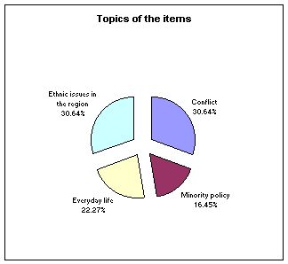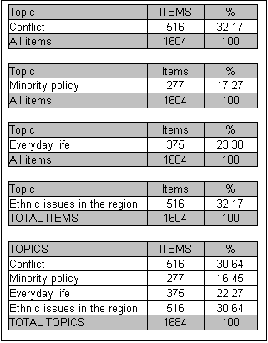

2. CONFLICT- RELATED REPORTING  Almost one third of the articles are directly devoted to conflict reporting: events that provoke, sustain, or perpetuate conflict.  Domination of conflict issues is obvious in countries with recent violent ethnic confrontation. It is more obvious in Kosovo, where it amounts to almost 80 percent than in Macedonia where it amounts to 45 percent of the articles. But an additional one fifth of the articles there deal with various conflict-motivated policy issues (22 percent) and various conflicts in the region (11 percent) making the overall conflict reporting more frequent.  Conflict coverage gets high visibility in countries geographically or historically close to violent ethnic conflicts. More than half of the articles in Serbia is directly conflict-related, and in neighbouring Montenegro about one third. In Bosnia-Herzegovina and Croatia, most conflict reporting investigates the past and is primarily presented as "truth revealing" coverage. In Croatia, all conflict-motivated reporting follows this pattern, and there is almost no coverage of reconciliation initiatives.  Conflict reporting differs in countries without recent violent ethnic confrontation. In Bulgaria, coverage never focuses on conflict but one fifth of minority news coverage focuses on their criminal activity. In Hungary, direct conflict-related reporting is also rare at 7 percent, but it is very frequent in Romania, at 37 percent.  Within three remaining topics -- ethnic issues in the region, everyday life and minority policy -- the most frequent individual issues are also potential conflicts or individual incidents.  The most extensively covered regional events are those in Kosovo and Macedonia, where crime takes up to one fifth of the coverage.  Considering all these various forms, conflict reporting dominates up to two thirds of the analysed content. | 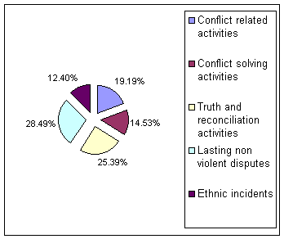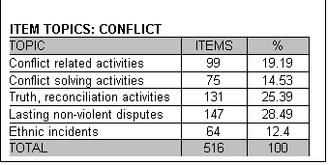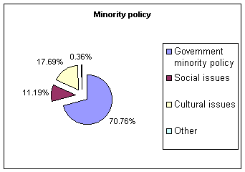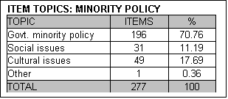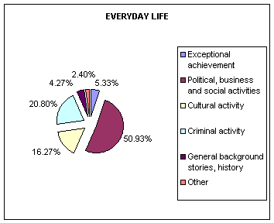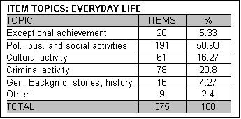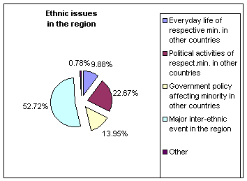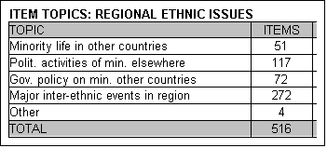

3. HIGHLY POLITICISED COVERAGE  Ethnic differences are presented as ethnic-political in almost 90 percent of the related articles.  Ethnic diversity is generally interpreted as a potential source of political problems and divisions. Stories about sport, culture, business, and everyday life -- that would provide for more positive and tolerant coverage of ethnic differences -- are all within the remaining 10 percent. Even within this part, almost half of the articles refer to crime in minority groups.  Ethnic issues is normally placed in political sections of the newspapers with over 40 percent on political pages, nearly one sixth on society pages, more than a quarter in international politics and slightly less than 5 percent on the front page. The ratio is even more striking in articles worthy of the front page: almost 80 percent are related to domestic political events and an additional 13 percent to international politics. In more stable and democratic environments, ethnic minority reporting is more diversified and more inclusive, where discrimination is less visible. Quite often sport and criminal pages are more relevant for research than political sections or front pages. In the Southeast European press, ethnic differences remain a highly politicised issue. | 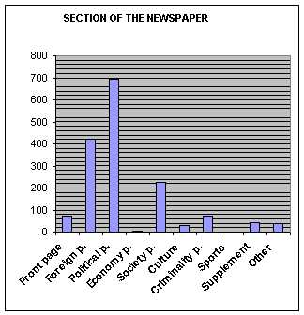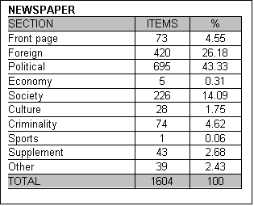

III PRESENTATION OF ETHNIC ACTORS  1. SELECTION OF MINORITIES  The region covered is ethnically very diverse. Out of 90 groups listed for analysis, thirty groups are noted as mentioned in the press, but only 10 attraced substantial coverage. At the same time, around a fifth of the articles had more than one actor. Sometimes they were from different ethnic groups and sometimes from the same, but with different social roles and positions in the article, and there are more actors than stories or topics.  Albanians are the most extensively covered minority in the region at almost 40 percent followed by Serbians and then Roma. The first two were directly involved in recent ethnic conflict, but Roma attracts the majority of discriminatory coverage throughout the region.  Ethnic actors deserve media attention when they are from minority groups in a conflict relationship with the majority.  Some ethnic groups receive much discriminatory reporting in more than one country. Over one fourth of Roma coverage has some discriminatory features (27 percent). Serbs and Albanians, as groups that are frequently reported on, are the target of discriminatory coverage in several countries at 17 percent and 15 percent, respectively.  Some minorities are often discriminated against only where they constitute a large minority, like Hungarians in Romania (almost one quarter) or Turks in Bulgaria (close to 10 percent). Some other groups are discriminated against only in certain countries: as with Jews in Hungary, or Croatia. Discriminatory coverage about Jews from these two countries constitutes one third of the articles carried about them in the region. | 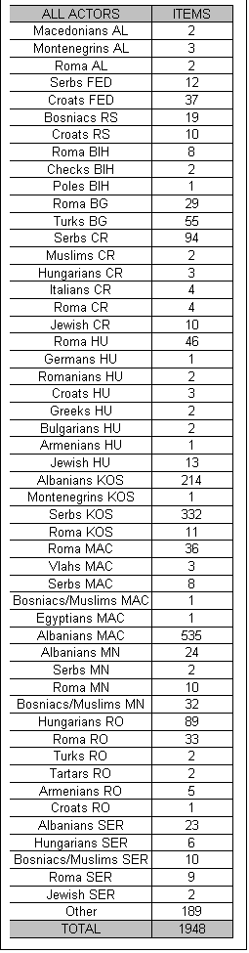

2. SOCIAL ROLES  Even when not openly discriminatory, coverage often depersonalises and socially devalues ethnic minorities. In various forms this is present in up to 60 percent of stories. This percentage corresponds to the amount of articles where others define ethnically -connected people, and where they are mostly only generalised and not quoted or paraphrased. This image problem appears to be a consequence of journalists' work, and not a real picture of minorities. | 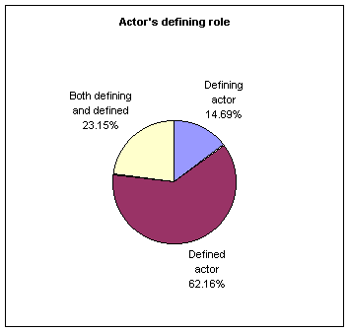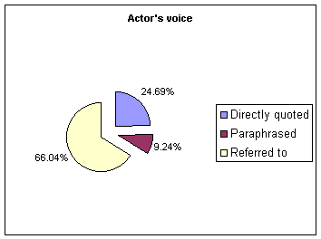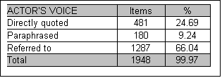

Ethnic actors appear mostly in various political roles (37 percent), as ethnic minority (29 percent) and in military roles (15 percent). Within the remaining 20 percent, most frequently they are victims as displaced peoples, returning refugees, or possibly in some professional role. The prevailing collective image of minorities leave whole ethnic groups appearing like single actors in mainly political or active military roles. | 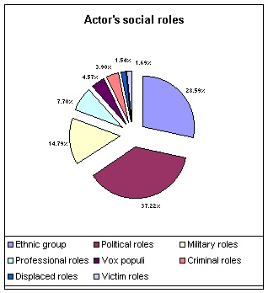

Ethnic groups seen as a whole is common at almost one half.  Individualised actors are mostly politicians and state officials. Criminals are counted as receiving double the attention of issue experts. Incident witnesses and anonymous participants of events are also occasionally individualised, but rarely ever is artists or celebrities at less than 1 percent.  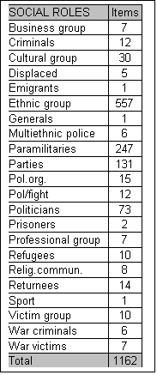 | 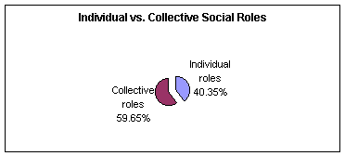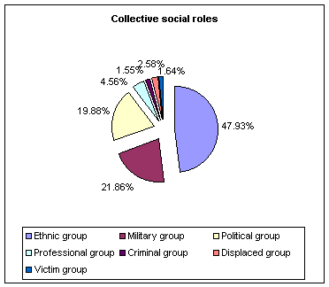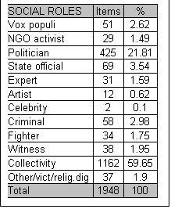

IV DISCRIMINATORY COVERAGE  1. MEDIA FORMAT  The development of tabloids - has generally results in depolitization of the press coverage including ethnic minorities. Where analysed papers differ clearly as "broadsheet" and "tabloid", as in Romania and Hungary, the amount of coverage in the former gets up to three times more than in the latter.  Where similar-format newspapers dominate the market, as with semi-tabloids like those in Croatia and Bulgaria, the difference is much less and usually within 10 percent. Where both newspapers are of similar format, but in opposing political positions, the differences is between 10 and 20 percent.  There are cases when the amount of discriminatory headlines, even completely discriminatory articles, is higher in the tabloid press.  The highest ratio is in Bota sot - of 25 articles, 19 have discriminatory headlines and 15 discriminatory content. There are also highly circulated broadsheets with very discriminatory content. Adevarul carried 15 discriminatory headlines and 26 discriminatory stories out of 81 articles. Nepsabadsag had 25 discriminatory headlines in 123 articles.  Discriminatory headlines are equally frequent in semi-tabloids, like in Vecernji list where 17 out of 51 articles have discriminatory headlines, or in Trud with 12 discriminatory headlines in 60 articles. | 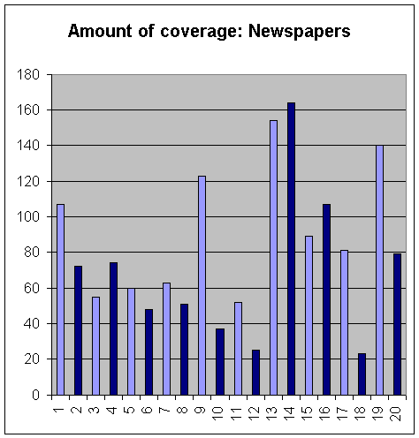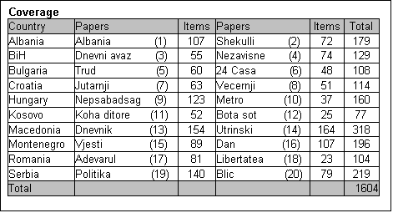

2. VISIBLE DISCRIMINATORY COVERAGE  Almost a fifth of the analysed coverage contains some visible discriminatory features and most of these are seen immediately in the headline.  More than 15 percent of the stories are titled discriminatorily or for sensationalism, which can spark prejudices. In all of the studied cases, article content is not entirely truthful, and this weighs into the role of journalists in their responsibility to fairness. An additional 3 percent of the articles are discriminatory in general approach, or presentation. This group includes only openly and clearly identifiable intimidating content. | 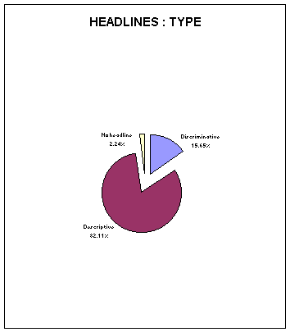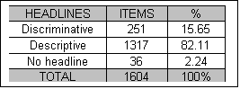

Many more items are potentially discriminatory, as up to 40 percent of the articles is interpretative with evaluation, prognostication or mobilisational content.  Such a high proportion of interpretative over descriptive writing offers room for judgment about actors and events, even when the facts is still not completely known in developing stories.  The amount of evaluative approaches corresponds to the distribution of story types and 40 percent fall into various interpretative genres. Varied informative stories account for another 45 percent with briefs and shorts taking up the last 15 percent. Feature articles total a third of the interpretative stories. These are stories that are not only, or necessarily, affected by events, but also by editors' decisions about the importance and timing in certain issues.  Interpretative articles double that of letters to the editor, but they vary across the region. Editorials are more frequent in Albania and Romania, but letters to the editor is more common in Serbia and Hungary. | 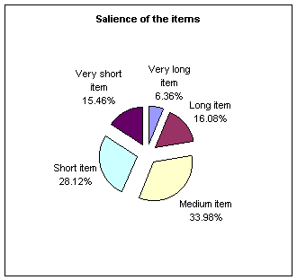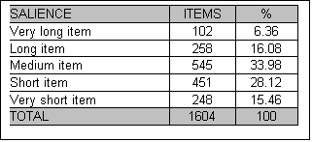

3. LESS VISIBLE FORMS OF DISCRIMINATION  Many less obvious forms of discrimination are also directly produced by inadequate journalistic practices.  Unprofessional, inconsiderate routines foster ethnic stereotypes and contribute to prejudices. This conduct supports and encourages beliefs that ethnic members are less active and socially less important.  In up to two thirds of the articles, ethnic actors are presented only in general terms. The absence of individual actors depersonalises ethnic members and stimulates their image as undifferentiated others.  In two thirds of the articles, people from other backgrounds define ethnic actors, and almost by the same percent these ethnic actors are neither quoted nor paraphrased. The press therefore intensifies their social passivity by not allowing them to self-define their actions. It follows information about their activities comes from other sources.  Minority actors are seldom seen in the newspapers. More than half of the articles about them have no visual material, and when they do it is limited to photographs in 40 percent of the cases. Those photographs are not always relevant to the text. | 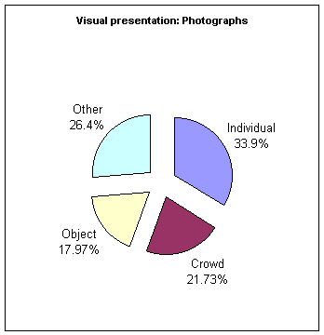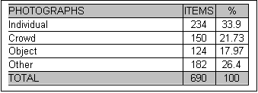

Nearly 85 percent of the articles do not treat events as individual occurrences. Too often they are generalised as typical for larger groups, even whole ethnic minorities.  Coverage is often conflicting, incidental and highly-politicised, so negative and conflict features are universalised and easily projected from the individual level to entire ethnic groups. | 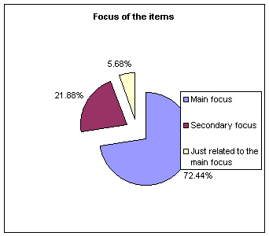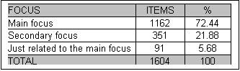

V MINORITY WITHIN MINORITIES  Women, already marginalised, are further discriminated against as members of ethnic communities.  As the majority of actors are described in terms of their social groups (such as Roma children, Kosovo non-Albanians, Albaninan politicial factors, Jewish community, Hungarians in Transylvania, Turkish business community etc.) there gender is not specified (62 percent).  When actors are individualised, women make up less than 3 percent of all of them: three and half times less than men at 35 percent.  Some social roles, however, connected with more power, transgress this rigid exclusion. Close to one third of the women serve in political, or government jobs (20 percent politicians and 10 percent state officials), making this their most significant individual social role. | 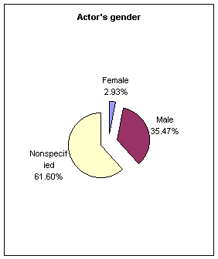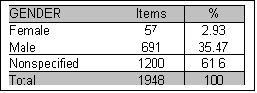

The majority of women appear in roles that comply with the dominant patriarchal pattern - women are mostly victims and witnesses of events (40 percent).  Women have a defining role in two thirds of the articles and in half of the stories they are quoted or paraphrased. Women often attract more media attention, however, in the more socially insignificant roles of witness, or person on the street opinionating on some question. This does not threaten the status quo as persons speaking from the lower end seldom undermine power relations.  Patriarchal structure of discrimination is, infects, most visible in disproportionate social roles assigned to men and women in South East Europe -male actors is mostly politicians and fighters female-witnesses and victims. | 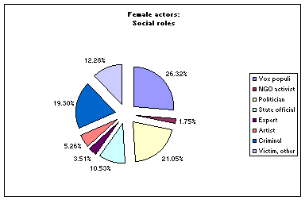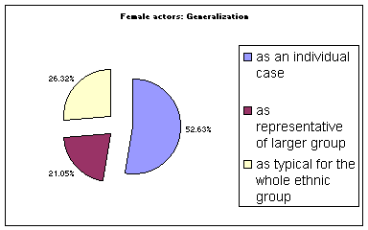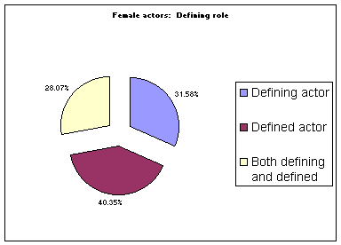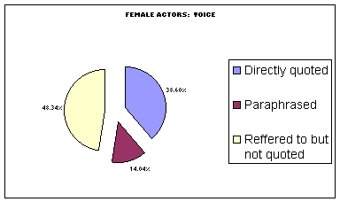

MAJOR CONCLUSIONS
Comparative content analysis of mainstream Southeast European press revealed both differences and common features in ethnic minority coverage.
• Differences between countries confirm that current political conditions and the quality of inter-ethnic relations affect reporting in obvious, but not necessarily equal ways.
• Similarities indicate that press coverage reflects the prevalent understanding of minority-majority relations, usually based on deep-rooted patterns of perceived otherness.
• Also, they point out some similar journalistic practices that contribute to poor diversity and toward intolerance through the press.
Therefore, major research findings demonstrate that:
1. Ethnic minorities coverage are related to political stability and the quality of inter-ethnic relations in each country.
• Politicised and conflict-related coverage increases under conditions of political instability and disharmony in ethnic relations.
• As conditions stabilise, both the amount of coverage and level of intolerance toward ethnic differences decreases.
• Increased invisibility and ignorance of ethnic actors or issues may also follow conflict resolution.
• In the absence of conflict, attention of the press quite often turns more toward ethnic communities in other countries - that is to say the minority there that is of the same ethnicity as their country's main group - rather than domestic minorities issues in their own country.
2. Widespread, deeply-rooted stereotypes and prejudices that govern common understanding of minority-majority relations is reflected in the press. They form patterns of perceived otherness that are often common throughout the region. These patterns influence the general approach to ethnic diversity and affect images of major ethnic groups regardless of political conditions.
• Ethnic diversity is generally a political issue. Difference are mostly comprehended and interpreted as politically significant: either as a threat to national unity or as a sign of difference, which could prompt political conflict. This reflects in ethnic distance between groups and toward mistrust of minorities.
• The common image of a minority group is one of a non-differentiated whole: presented through collective groups rather than individuals, whose members are mostly male and behave in similar ways. This complies with a stereotypical view that they are all the same, and that ethnic origin is crucial in the behaviour of minority members.
• Almost without exception, there is an ethnic group in each country that attracts most of its discriminatory reporting. It are always a significant group -- either large, or with a long history of tensions with the majority, and often commonly discriminated against in the region.
3. Media standards and journalistic practices that contribute to poor diversity and intolerance are often common throughout the region. This kind of behaviour by journalists supports and encourages beliefs that ethnic members is less active and socially less important .
• Varied and competing newspaper formats prompt higher media standards that also affect minority coverage. Compared to broadsheets, tabloids clearly depoliticise coverage as they have less content, is less analytical, and carry less interpretative reporting. Tabloids introduce more simplified, sensational and some discriminatory coverage. Minority issues require a cautious and tolerant understanding of differences and most tabloids are not likely to provide that.
Inadequate journalism standards contribute directly to a depersonalised and passive image of ethnic peoples. Quite often they are not quoted or visually presented, nor do they get a chance to self-interpret their activities. Additionally, gender structure of ethnic groups reveals multiple discrimination -- women, already marginalised, are further discriminated against when from ethnic communities.
Journalism, more sensitive to ethnic diversity, would provide better room for excluded groups in Southeast European societies.
BACK TO TOP

